Dartmoor National Park Tour
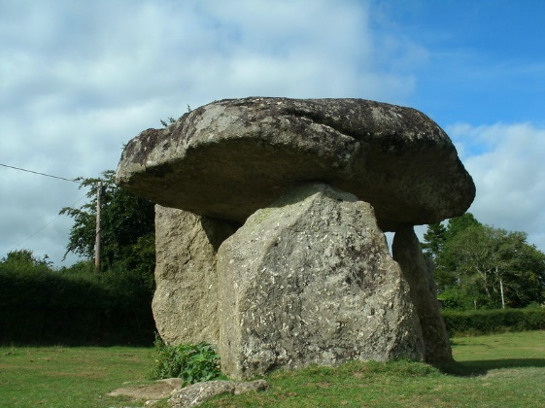
Site Name: Spinsters' Rock Alternative Name: Spinster's Rock; Grinsell List A Drewsteignton 1
Country: England County: Devon Type: Burial Chamber (Dolmen)
Nearest Town: Okehampton Nearest Village: Drewsteignton
Map Ref: SX70109079 Landranger Map Number: 191
Latitude: 50.702199N Longitude: 3.840851W
https://www.megalithic.co.uk/article.php?sid=149
Burial Chamber (Dolmen) in Devon. The burial chamber is composed of a large capstone supported on three uprights. The tomb collapsed in 1858 and was reconstructed soon afterwards, but not exactly as it had been originally.
It was apparently erected by three spinsters before breakfast, hence the name!
Update December 2019: This dolmen is featured on the Prehistoric Dartmoor Walks (PDW) website - see their entries for the Spinsters Rock Chambered Tomb and Spinster's Rock.
The tomb is also recorded as Pastscape Monument No. 445766, as MDV8440 (Spinster's Rock, Drewsteignton) on the Devon and Dartmoor HER, and scheduled as Historic England List Entry No. 1003177

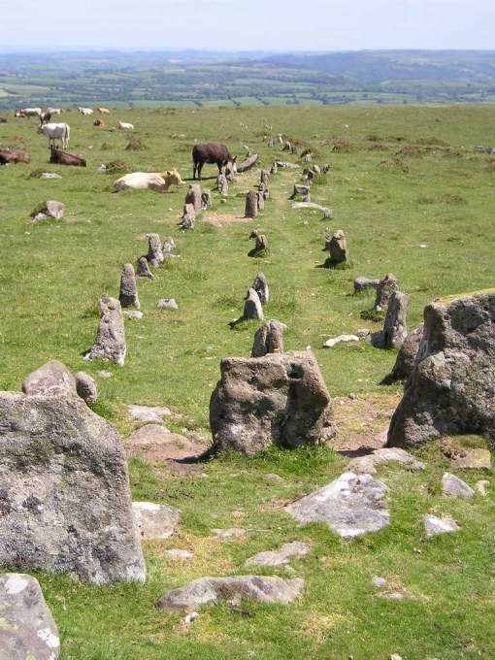
Site Name: Cosdon Hill Multiple Stone Rows Alternative Name: The Graveyard
Country: England County: Devon Type: Multiple Stone Rows / Avenue
Nearest Town: Okehampton Nearest Village: South Zeal
Map Ref: SX64349159 Landranger Map Number: 191
Latitude: 50.708073N Longitude: 3.922664W
https://www.megalithic.co.uk/article.php?sid=1858
On a flattish shelf of land on the eastern side of Cosdon Hill, Dartmoor, are the splendid remains of a cairn and treble stone row.
The three parallel rows run off down the hillside from the cairn in an approximately easterly direction, spaced about 1.5 metres apart, for a distance of at least 140 metres, perhaps up to 180 metres to where possibly a large triangular blocking stone can be found.
The rows are not straight, and curve slightly to the south, then back north down the hill. As usual, the larger stones are near to the cairn, between 2 and 3 feet high, and they generally get smaller the further away from the cairn they are, with a few notable exceptions.
Each of the rows has a large slab placed across the rows at its end by the cairn, but these are perhaps not their original positions, and do not line up with each other.
The upper part of these rows survives in a very good state, but the lower part of the rows remain in a much more ruinous or buried state. Partway down the rows, an old track has been driven through the rows, but even here, stones still remain standing between the two sections of the cut track way.
A smashing place to while away some time.
Update September 2019: This stone row is featured on the Prehistoric Dartmoor Walks (PDW) website - see their entry for the Cosdon Stone Row, which tells us: "(this is) a triple stone row lies near the summit of Cosdon Hill and is 447 feet in length measured from the centre of the circled cairn which stands at the west end. At 225 feet from the west end there is a slight change in direction and the rows turn somewhat northward. This change of direction may be said to divide the row into western and an eastern section".
The row is also recorded as Pastscape Monument No. 444168, which adds that: "Of the two cists, one is intact, the other has been robbed of the cover-stone and two side-stones. The foot-stone of one cist also served as the headstone of the other". The row is also scheduled as Historic England List ID 1013426 (Triple stone alignment and cairn 780m east of Cawsand Beacon).
The Devon and Dartmoor HER also includes an entry: MDV6886 (Triple stone alignment and cairn 780m east of Cawsand Beacon).
The row is also recorded in the Stone Rows of Great Britain website's entry for Cosdon, which includes a description, photographs, a simplified plan of the triple stone alignment, plus access information.

Site Name: Scorhill
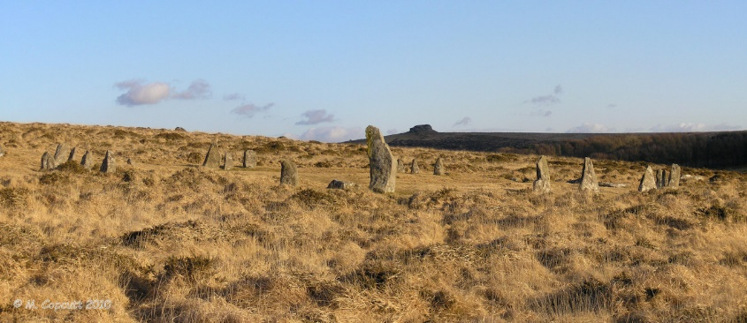
Alternative Name: Gidleigh Circle; Turner G6 Butler (map 38.8)
Country: England County: Devon Type: Stone Circle
Nearest Town: Chagford Nearest Village: Teigncombe
Map Ref: SX65468738 Landranger Map Number: 191
Latitude: 50.670495N Longitude: 3.905277W
https://www.megalithic.co.uk/article.php?sid=540
Scorhill Stone Circle and Standing Stone on Scorhill Down, northeast Dartmoor, with it's dramatic setting on the rugged moorlands makes this 26.8m (88-foot) circle a worthwhile visit.
Only thirty-four stones remain of an original sixty-five to seventy, and only twenty-five of those are still standing. Two cart-tracks run right through the ring, making its appearance even more dramatic. The stones are not evenly spaced, and the tallest, at 2.5m (8 feet 2 inches), is located in the NW. There is a prostrate massive slab,1.8m (6 feet) long and 1.5m (5 feet) wide, slumped at the SSW. The 2.4m (8-foot) pillar at the NW is set radially to the perimeter of the circle, and its alignment with the most northerly moonrise from the centre of the circle might indicate an attempt to incorporate astronomy into the construction of the circle.
Update December 2019: This stone circle with its associated standing stone is recorded as Pastscape Monument No. 443556, as MDV6122 (Stone Circle, Scorhill Down), and scheduled as part of Historic England List Entry No. 1018915 (Scorhill stone circle, three cairns and a length of reave).
The stone circle is also featured on the Prehistoric Dartmoor Walks (PDW) website - see their entries for the Scorhill Stone Circle, the Scorhill Circle Standing Stone and the Schorhill Stone Circle (Walk). PDW describes this site as "one of Dartmoor's most attractive sites".
Access: Short walk from Batworthy Corner, over clapper bridge crossing River North Teign, or a small parking area is available at Scorhill farm.

Site Name: Shovel Down
Country: England County: Devon Type: Multiple Stone Rows / Avenue
Nearest Town: Chagford Nearest Village: Teigncombe
Map Ref: SX65958599
Latitude: 50.658115N Longitude: 3.897843W
https://www.megalithic.co.uk/article.php?sid=10387
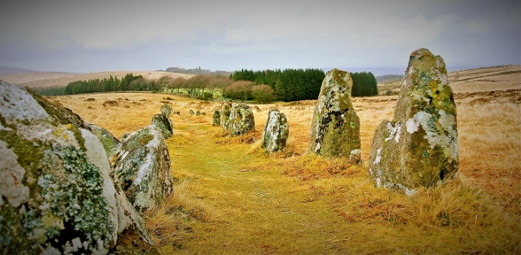
Near the northeastern corner of Dartmoor, to the west of the old stannary town of Chagford at Shovel Down, are a multitude of remains which together make up the Shovel Down complex of ceremonial sites.
The site includes an open stone circle, a fourfold cairn circle, a long single stone row, 6 double stone rows or avenues, a giant longstone, several other standing stones, several cairns, and the remains of an ancient settlement.
Access to these sites is fairly easy for Dartmoor, by driving west from Chagford to Batworthy Corner, right up on the moor, where a few parking spaces are available. From here it is only a short walk along a fairly well defined trackway until the first of the sites is encountered. There are many other trackways here, which will take the visitor around most of the rest of the sites. In fact, there is a trackway which runs right along the north south axis of the site, which is part of an ancient trackway from Scorhill in the north to Fernworthy in the south, which no doubt is here because of the ancient avenues and rows which it follows.
The visitor here is walking in the footsteps of 4000 years of our ancestors.
Update December 2019: This complex is also featured on the Prehistoric Dartmoor Walks (PDW) website - see their entries for the Shovel Down Ceremonial Complex and the Shovel Down Complex. PDW also includes separate entries for the individual stone rows, standing stones and cairns (see the individual pages on the 'nearby sites below' for more information).
More information can also be found on Pastscape Monument No. 443524 and as part of the scheduling information for Historic England List ID 1017874 (The North Teign coaxial field system (western part) and associated later remains at Shovel Down, Stonetor Hill and Long Ridge).

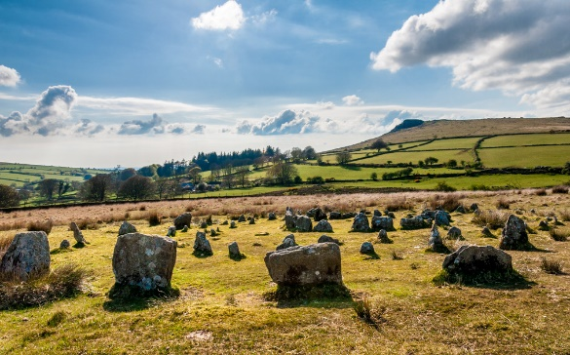
Site Name: Yellowmead Alternative Name: Sheepstor 4 (Grinsell); G30 (Turner); Yellowmead Down
Country: England County: Devon Type: Stone Circle
Nearest Town: Tavistock Nearest Village: Sheepstor
Map Ref: SX57486784 Landranger Map Number: 202
Latitude: 50.492983N Longitude: 4.010637W
https://www.megalithic.co.uk/article.php?sid=1371
Four Concentric Stone Circles in Devon. This site was restored in 1921 and consists of four concentric stone circles, one of which surrounded a cairn, now badly ruined. A stone row runs to the south-west.
What an amazing site this is. On gently sloping hillside facing Sheepstor from the southeast can be found this tremendous fourfold stone circle, marked as Cairn circles on the OS map, about 20 minutes boggy walk from parking near what is known as the Scout Hut.
The site consists of four approximately concentric circles of stones, with several more stones arranged around the western circumference, which are possibly remnants of a series of rows that radiated outwards downhill from the circles. The innermost circle is about 6 metres in diameter, and made from nice slabs set closely to each other. The outer circles are made from slabs of varying size, with diameters increasing by about 5 metres a time. Some of the stones in the outer circle are very big by comparison to the majority. I found it almost impossible to get any photographs which do any justice to this site. A challenge set to you photographers out there.
A short distance uphill to the northeast from these circles is the remains of a small cairn, with a surrounding ring of stones (see nearby sites below).
Update July 2019: This site is recorded as Pastscape Monument No. 438550, and scheduled as Historic England List ID 1010212. Further information can also be found on Prehistoric Dartmoor Walks's Yellowmead Fourfold Stone Circle, and Stone Circles: Yellowmead.
The entry for Legendary Dartmoor: Yellowmead Circle gives us details of the discovery and restoration of this four-fold stone circle. "During the whole process only one was brought in from elsewhere and erected in the outer circle, (Petit, 1974, p.102)". Butler, in his "Dartmoor Atlas of Antiquities", volume 3, page 74 also includes a description and plan of the stone circle. The stone circle is also featured on the Stone Rows of Great Britain website - see their entry for Yellowmead Down Stone Row, which also includes a plan of the stone circle and its row(s).

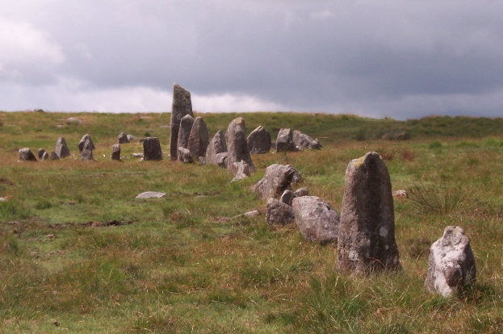
Site Name: Down Tor stone row Alternative Name: Hingston Hill
Country: England County: Devon Type: Stone Row / Alignment
Nearest Town: Princetown Nearest Village: Sheepstor
Map Ref: SX59026939 Landranger Map Number: 202
Latitude: 50.507286N Longitude: 3.989525W
https://www.megalithic.co.uk/article.php?sid=1901
Down Tor (Hingston Hill) stone row, SX 5902 6939 to SX 5868 6927.
This spectacular row was re-erected in 1894 and must look much as it did when first erected. The 39' diameter cairn at the western end of the row has 27 irregularly spaced stones, the two tallest being 3'6" high. There are 2 flat slabs in the central hollow of the cairn which may be the remains of a kistvaen.
The huge pillar next to the cairn weighs about 3 tons. The whole site seems to have been chosen to enhance the impact of its appearance with the ground rising gradually towards both ends of the row from the lowest point at its centre.
Update November 2019: This stone row is featured on the Prehistoric Dartmoor Walks (PDW)website, - see their entries for the Hingston Hill (Down Tor) Stone Row, the Hingston Hill (Down Tor) Standing Stone, the Hingston Hill (Down Tor) Stone Row, and the Down Tor Stone Row and Cairn Circle.
The site is also recorded as Pastscape Monument No. 438583, as MDV3502 (Down Tor Stone Row, Walkhampton) on the Devon and Dartmoor HER, and scheduled as Historic England List Entry No. 1009090 (Stone alignment and cairn 830m east of Down Tor).
The row is also recorded on the Stone Rows of Great Britain website - see their entry for Hingston Hill, which includes a description, photographs (including one of the kerbed cairn at the upper end of the alignment, and another of the eastern cairn). The SRoGB also includes evidence and illustrations of how viewpoints appear and disappear as you walk along this 351m long row with its 157 stones.
The SRoGB also includes a separate entry for Sea Views at Hingston Hill, which discusses and illustrates the different views which are visible as you progress along the row.

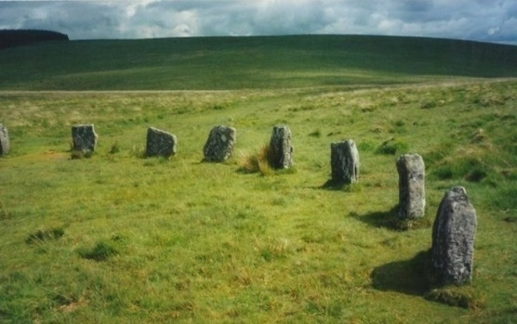
Site Name: Grey Wethers. Alternative Name: Gray Wethers, Greywethers, Turner G2
Country: England County: Devon Type: Stone Circle
Nearest Town: Okehampton Nearest Village: Chagford
Map Ref: SX63878313 Landranger Map Number: 191
Latitude: 50.631928N Longitude: 3.926201W
https://www.megalithic.co.uk/article.php?sid=532
The walk to this double-ringed circle is long and tedious, but well worth the effort. Excavated in 1898 and restored in 1909, they contained charcoal bits throughout. Attention to detail during construction is obvious in that the circles stand almost exactly north-south of one another.
Standing 4.6m (15 feet) from one another, the north circle is 32.7m (107 feet) in diameter while the other is a mere 20cm (8 inches) larger. Now well restored, they were erected below the crest of north-facing slope, along a pass between two hills. Of course JJ didn't bother to walk, but flew over instead! (see aerial photo below)
Access: Continue along the main forest track west from Fernworthy stone circle for a kilometre or so, until you reach a gate onto the open moor. From here, turn south and head up to the saddle of the land between the forest on your left, and Sittaford Tor on your right at just over a kilometre distance.
Update October 2019: This stone circle is featured on the Prehistoric Dartmoor Walks (PDW) website - see their entries for the Grey Wethers (S) Stone Circle and the Grey Wethers Double Stone Circle. PDW tells us: "This site is one of the most impressive on Dartmoor. The circles were restored in 1909 by Burnard. At the time only 9 stones remained standing in the north circle and 7 in the south circle. It is thought that the reconstruction is fairly accurate. The circles are separated by a few meters and are almost identical. Both circles have 30 stones".
The two stone circles at this location are recorded as Pastscape Monument No. 443916 and on the Devon and Dartmoor HER as MDV6759 (The Grey Wethers southern stone circle).
Both stone circles were recorded as Historic England List ID 1018707 (Two stone circles known as The Grey Wethers, three round cairns, two ring cairns and an oval enclosure in Great Stannon Newtake).

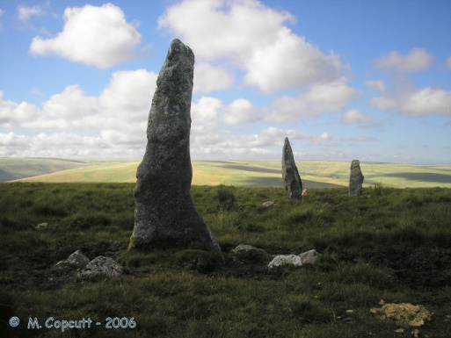
Site Name: Stalldon Row Alternative Name: The Cornwood Maidens, Stalldown Row
Country: England County: Devon Type: Stone Row / Alignment
Nearest Town: Ivybridge Nearest Village: Cornwood
Map Ref: SX63236248 Landranger Map Number: 202
Latitude: 50.446179N Longitude: 3.927661W
https://www.megalithic.co.uk/article.php?sid=531
This magnificent stone row stretches for over 500 metres in a north to south direction, mostly up the southern slopes of Stalldon Barrow hill, but with its northerly end just over the top of hill, and starting to wander back down the northern hillside.
The northern end of the row (SX637607) has 4 wonderful large (2 metres plus) stones still standing, with a further two large slabs fallen at the northern end, one of which was possibly a large side set slab forming a blocking stone. These four large stones can be seen from miles away all over the southern moor, and look in many ways like four walkers on the hilltop. The rest of the row consists of stones mostly just about a metre high, but some are quite a bit more. There’s a horse skull placed on top of one of the stones when I visited, which really sets it off nicely.
The row is not very straight, nor is the spacing of the stones very regular, and indeed looks to be perhaps two rows meeting at a circular cairn structure, of diameter 5 metres, and including two large pillars, just to the south of the hilltop. The northern part of the row aligns to the centre of the cairn circle, while the row to the south passes besides the western side of this cairn, before running off down the steep hillside to the south.
The lower part of the row seems to terminate at a large side set slab (SX637602) but it is possible that the original row continued for several hundred more metres to a cairn, and several buried slabs are to be found which may once have been part of the row.
Quite how much of today’s standing row is original is open to debate, as the whole structure underwent a “restoration” in about 1897, so it is possible that the misalignment of the two parts is not an original feature, and that the original structure was a much more straight and evenly spaced row.
Apart from the circular cairn beside the row near the top of the hill, there are several other cairns around and about on the hill here, one or two of which can still be seen to have their central cists in place.
This stone row is fantastic. It moves up into the top 5 stone rows I know, and perhaps my favourite stone row on Dartmoor. It is not only a tremendous row of big stones marching over the top of the hill, but sat by the central circular cairn, the views are superb. To the north, the wild moorland stretches off into the distance, while to the south, way below, are all the patchwork of fields of south Devon and then the beautiful blue sea. Plymouth sound, with its ships can clearly be seen to the south west.
Magnificent.
Update November 2019: This alignment is featured on the Stone Rows of Great Britain website - see their entry for Stalldown, which includes a description, a plan of the row and its associated cairns, photographs of the alignment and some of its individual stones and cairns, access information and a list of online resources for more information.
The SRoGB also includes an additional page to discuss and illustrate the Sea Views at Stalldown.
Prehistoric Dartmoor Walks (PDW) also features a page for this row - see their entries for the Stalldown Stone Row and the Stalldown Stone Row and Terminal Cairn.
The row is also recorded as Pastscape Monument No. 442211, as MDV4277 (Stone Row on Stalldown, Cornwood) on the Devon and Dartmoor HER, and scheduled as Historic England List Entry No. 1015806 (Stone alignment and cairns on Stalldown).

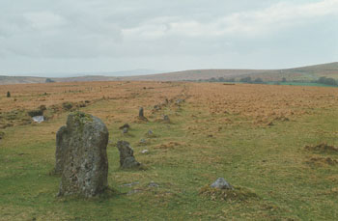
Site Name: Merrivale North Row Alternative Name: Merrivale 1; Worth Merrivale A; Butler Merrivale 1
Country: England County: Devon Type: Multiple Stone Rows / Avenue
Nearest Town: Tavistock Nearest Village: Princetown
Map Ref: SX55457479 Landranger Map Number: 191
Latitude: 50.554946N Longitude: 4.041932W
https://www.megalithic.co.uk/article.php?sid=2044
Double Stone Row making up part of the Merrivale complex on western Dartmoor in Devon
There are two, main, rows at Merrivale - North and South. The north row consists of two lines of stones, aligned east -west and nearly 200m long. However, the two lines of stones are only about 1m apart so you can only just walk between them. It has larger stones at the west end and a blocking stone at the east, where there is also the remains of a carin with its surrounding stone circle.
There are a number of sources of information for this row. See:
Pastscape Monument No. 440056 (see the paragraphs relating to Row A, north row);
The Devon and Dartmoor HER: MDV14797 (Merrivale Stone Row A, Dartmoor Forest);
Historic England's scheduling information for List ID 1013429 (Three stone alignments, ten cairns, three stone hut circles and a length of the Great Western Reave on Longash Common);
Stone Rows of Great Britain: Merrivale 1, which includes a description, a plan of the monuments at Merrivale showing their relationship to each other, photographs, access information and a list of online resources for more information;
Prehistoric Monuments of Dartmoor: Merrivale A; and
Prehistoric Dartmoor Walks (PDW) - see both Merrivale A Stone Row and Merrivale Ceremonial Complex [Photo Set 1].

